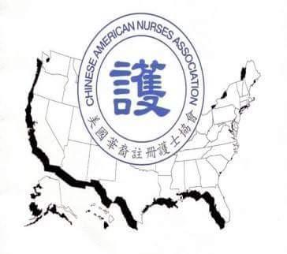
Chinese American Nurses Association
美國華裔註冊護士協會
28th Annual Fundraising Gala
Friday, May 8, 2026
Name___________________________________________________ Title_________________________________
Organization___________________________________________________________________________________
Email_________________________________________________________________________________________
Address_______________________________________________________________________________________

RSVP | Sponsorship Level | Amount | Description
__ Yes | Diamond Sponsor | $3,600- | VIP table (10 persons)  Diamond Page Advertisement  - Full Color Back Cover Page or  - Full Color Inner Front cover or  - Full Color Inner Back Cover  Logo featured during the event.  Logo on CANA website for 1 year.
__ Yes | Platinum Sponsor | $3,100- | VIP Table (10 persons)  Platinum Full Color Page Advertisement  Logo featured during the event.  Logo on CANA website for 1 year.
__ Yes | Gold Sponsor | $2,600- | VIP Table (10 persons)  Full Page Color Advertisement  Logo featured during event
__ Yes | Pearl Sponsor | $1,000- | Full Page Color Advertisement
__ Yes | Silver Sponsor | $800- | Half Page Color Advertisement
__ Yes | Bronze Sponsor | $600- | ¼ Page Color Advertisement
__ Yes | I/We will attend the Gala.  Please reserve seats. | $160/each $1,500/table  $50/each  $10/each | Reserve___ seat/s for non-member  Reserve___ table/s  Reserve ___ seat/s for active CANA member  Reserve___ seat/s for active CANA student member
__ Yes | I/We will not be able to attend, but enclosed is my donation of $_______ to help support CANA |  | Your donation is tax-deductible
*All advertisements sizes are based on 8.5”x11” portrait sized paper.
Deadline for all advertisements is Monday, April 17, 2026.
No dinner tickets will be sent. All reservations will be listed by name. To guarantee reservations, checks must be received by April 24, 2026.
Please make all checks payable to "Chinese American Nurses Association." Mail check/s and sponsor form to: Chinese American Nurses Association. P. O. Box 527652, Flushing, NY 11352 or to pay online, please visit www.cana-usa.org (use our PayPal Donations button), and email the sponsor form to cananursing1997@gmail.com For inquiries, reservations, and confirmations, please text:
Ms. Christine Lee @ 646-564-2676 or Ms. Maria Poon @ 917-751-6863 or email us at cananursing1997@gmail.com.

