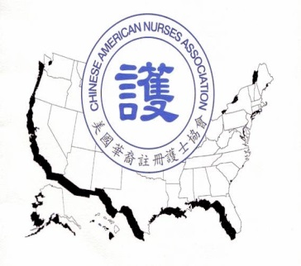
Chinese American Nurses Association
美國華裔註冊護士協會
P.O. Box 527652
Flushing, NY 11352
Cananursing1997@gmail.com

Nursing Continuous Education Funding Application
MEMBER INFORMATION
Name:_____________________________________________________________________
First Last
Gender: M____ F_____
Address:____________________________________________________________________
City______________________ State _____________Zip Code___________________
Day Telephone: _______________________ Cell: ___________________________________
Email Address: ______________________________________________________________
Active CANA Member Yes_____ No ______
WORKSHOP INFORMATION
Name of Certifying Organization______________________________________________
Name of the Workshop ________________________________________________________
Start Date of the Workshop _____________ Completion Date of the Workshop ____________
Actual Workshop Fee __________________________________________________________
Number of CEU credits (if applicable)______________________________________________
I acknowledge that all the information contained on this application is correct and that any false information may disqualify me from any future sponsorships, scholarships, etc.
Applicant’s Signature (not typed): _______________________________ Date:____________
Please email or mail the application form to CANA at the above address.

